Reflection Paper - Design Decisions
Final Project CS-330-T5527
Computer Graphic and Visualization 23EW5
Scott Dixon
June 18, 2023
The application I have chosen for the final project is a virtual scene that uses OpenGL and C++ to visualize a countertop and cutting board along with silverware, an apple, a lemon, a cup, a glass, and an iPhone. Quite a few different objects needed to be created in OpenGL, although some aspects of building the objects could be used multiple times. The scene is created using Modern OpenGL, GLSL, and texture files that all add up to a realistic version of the original setting. The process of setting up the OpenGL environment includes:
- Addition of the necessary OpenGL libraries and headers in the development environment which includes C++ to run the project.
- Creation of an OpenGL window where I can render your 3D scene.
- Setting up any other requirements, such as viewport size and projection matrix.
At that point, I realized that I needed to set up some beginning points or vertices to provide structure to my virtual world. There are a total of 5 different coordinate systems that are important to me as noted on the website learnopengl.com:
- Local space (or Object space)
- World space
- View space (or Eye space)
- Clip space
- Screen space

I chose to begin with a matrix that created a cone, a rectangular box, and a cylinder. Later I decided that the mesh needs a more simplistic set of triangles to fashion a rudimentary fork for my scene. Next, I needed to load and position objects in the viewport. The shapes needed to recreate the 2D image. These shapes include cubes, spheres, cylinders, and disks depending on the complexity of the images that I wanted to make.
I defined the vertices, Normals, and texture coordinates for each shape and went on to decide where the objects were going to live in my new virtual world. I was getting creative! I decided to explore some external libraries and modeling software and found a complimentary yearlong subscription to 3D computer-aided design software. I loaded the vertex data into the OpenGL buffers and went on to the next step to bind them appropriately.
Although the position and scale of the objects in the 3D scene might be a simple task If I were able to click and drag the objects around the scene, this was not the case as it became necessary to set up a point of reference for each of the desired “approximate” locations of the objects. This is where the difficulty in setting up the scene began. After a long time trying to set up the location for each of the objects, I found a few great videos on YouTube that pointed me in the right direction. I began to feel a sense of accomplishment when I pressed the F5 key on the keyboard and the virtual scene began to compile and appear on the screen.
In today’s professional landscape, realistic computational graphics and visualizations are in high demand.
"
"
The video game industry needs images rendered that are increasingly life-like and realistic looking.
Below is a view of my completed scene: 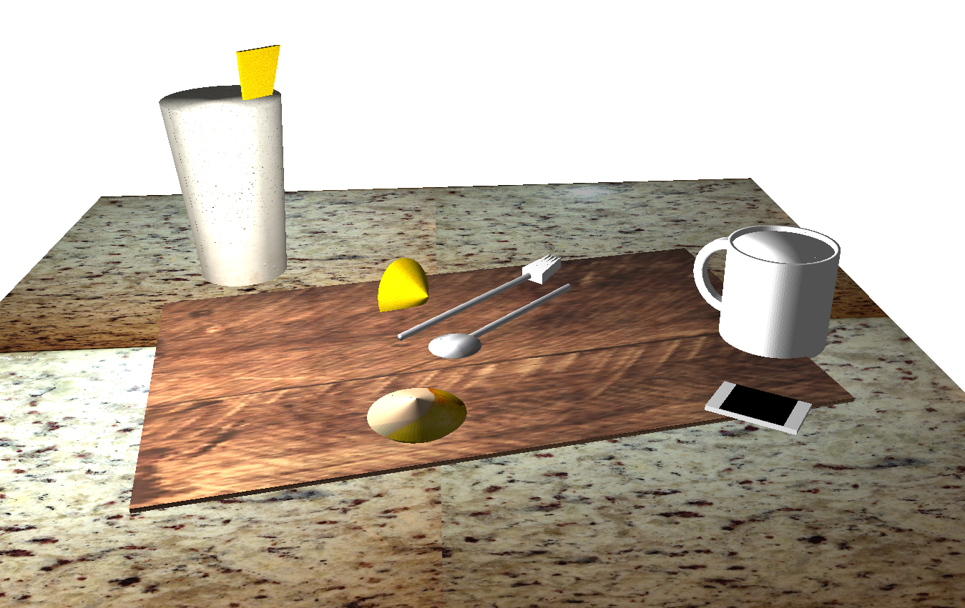
To access the special options available in this program:
Press O for orthographic projection.
Press P for regular perspective.
Press Esc to halt the program.
To move around in the scene:
Press W to move forward.
Press S to move backward.
Press A or D to move left or right.
Press E or Q to go up or down.
Press T or Y to change the spotlight position along the x-axis. (This will create an intense number of shadows cast on the objects with the T key and lessen the effect with the Y key.)
Press the 8, 9 or 0 keys to change the color spectrum that is cast on the scene. (8 is a bluish hue, 9 is reddish and 0 is a sunset-like tan hue.)
Press V or B to toggle on or off the spotlight ambient hue.
Press H or G to toggle on or off the spotlight movement around the virtual scene. (This controls the lighting that replicates the movement of the sun and renders shadows and light in an orchestrated dance.)

References:
https://learnopengl.com/Getting-started/Coordinate-Systems Sourced 06/18/2023.

